Task 1: Transit Gateway Setup -
Establishing Inter-VPC Connectivity Using AWS Transit Gateway
Objective:
Design and deploy a scalable network architecture using AWS Transit Gateway to enable secure communication between multiple VPCs.
Architecture Example:
VPC-A: 192.168.1.0/24
VPC-B: 192.168.2.0/24
VPC-C: 192.168.3.0/24
Transit Gateway: Central Hub
Step 1: Create VPC-1 (Default)
Go to AWS Console → VPC → Your VPCs → Create VPC
Name: VPC-1
CIDR: 192.168.1.0/24
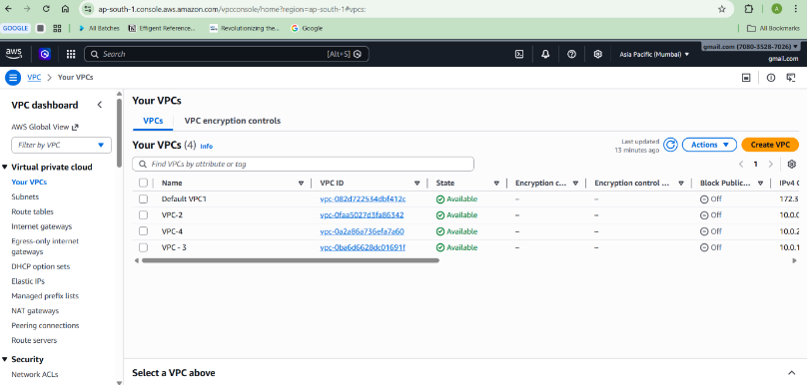

Step 2: Create VPC-2
Go to AWS Console → VPC → Your VPCs → Create VPC
Name: VPC-2
CIDR: 10.0.0.0/28
Step 3: Create VPC-3
Go to AWS Console → VPC → Your VPCs → Create VPC
Name: VPC-3
CIDR: 10.0.1.0/28

Step 4: Create VPC-4
Go to AWS Console → VPC → Your VPCs → Create VPC
Name: VPC-4
CIDR: 10.0.2.0/28

Step 5: Create Subnet in VPC-1 (Default)
Go to Subnets → Create Subnet
Select VPC-1
CIDR: 192.168.1.0/25
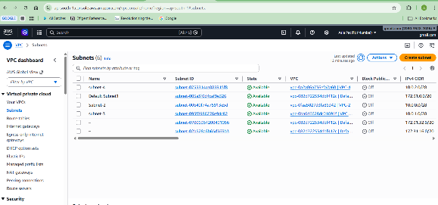
Step 6: Create Subnet in VPC-2
CIDR: 10.0.0.0/28
Step 7: Create Subnet in VPC-3
CIDR: 10.0.1.0/28
Step 8: Create Subnet in VPC-4
CIDR: 10.0.2.0/28
Step 9 : Create Transit Gateway
Go to VPC → Transit Gateways → Create Transit Gateway
Name: My-Transit-Gateway
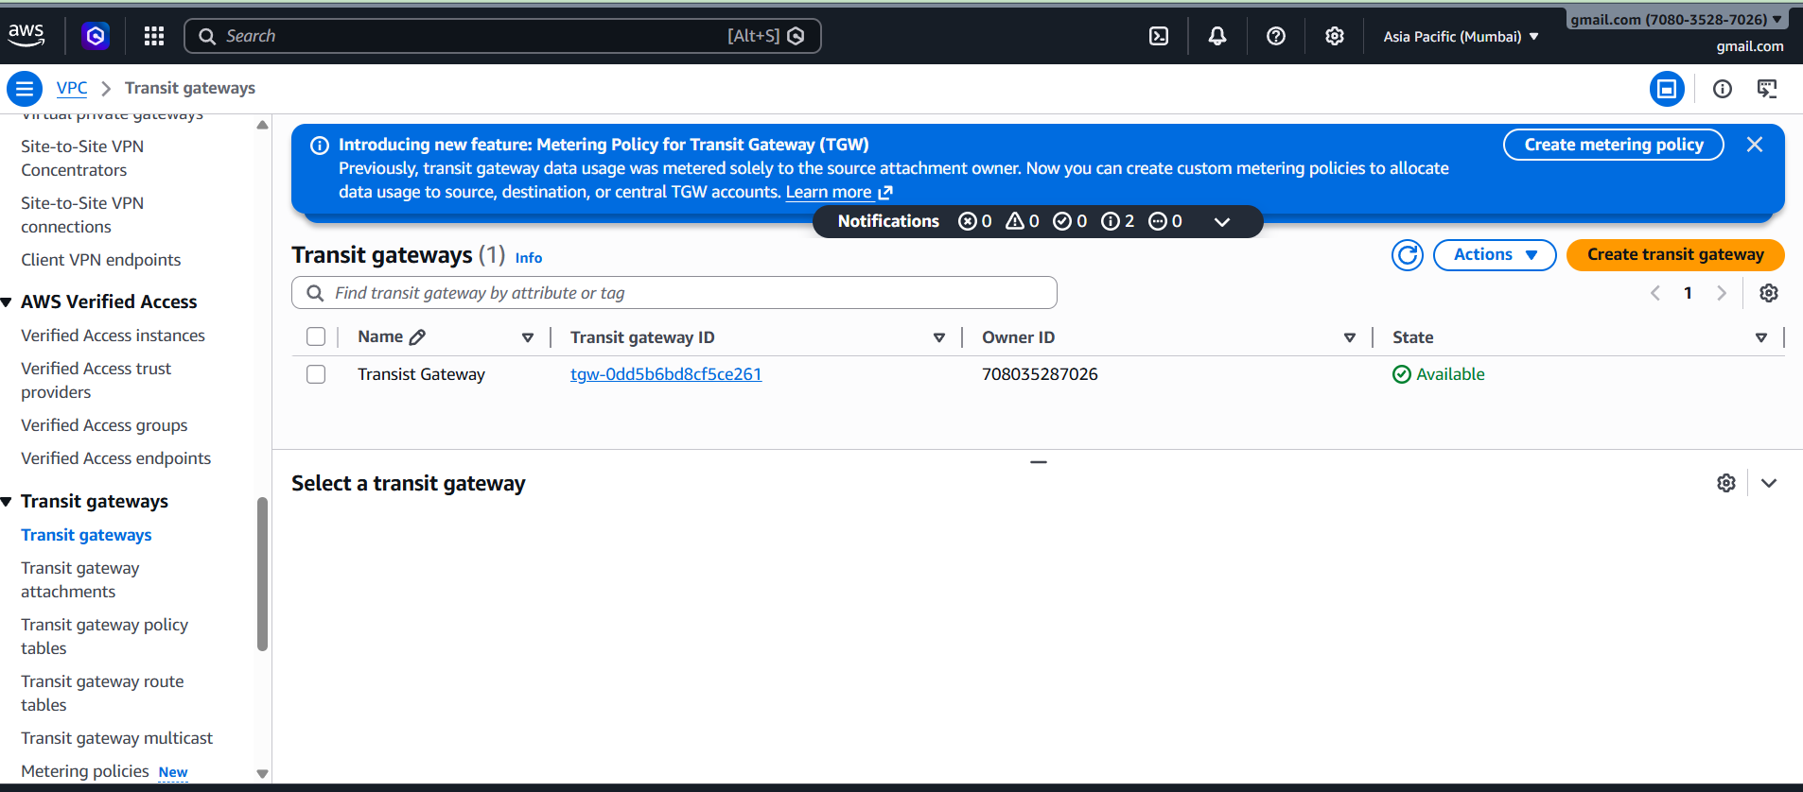

Step 10: Attach VPC-1 to Transit Gateway
Transit Gateway Attachments → Create attachment
Select VPC-A and subnet
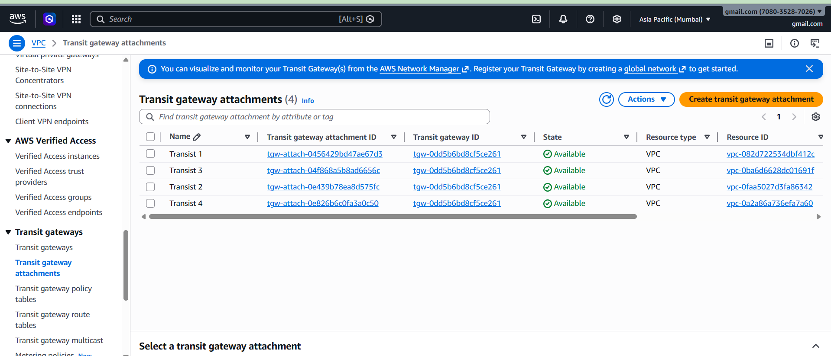
Step 11: Attach VPC-2 to Transit Gateway
Repeat same process

Step 12: Attach VPC-3 to Transit Gateway
Repeat same process

Step 13: Attach VPC-4 to Transit Gateway
Repeat same process

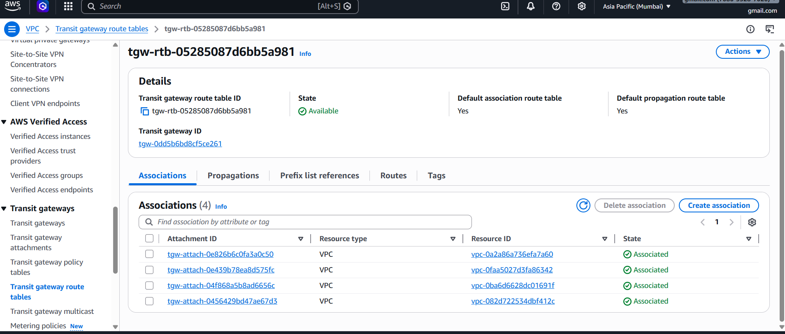

Step 14: Update Route Table of VPC-1
Add routes:
192.168.2.0/24 → Transit Gateway
192.168.3.0/24 → Transit Gateway
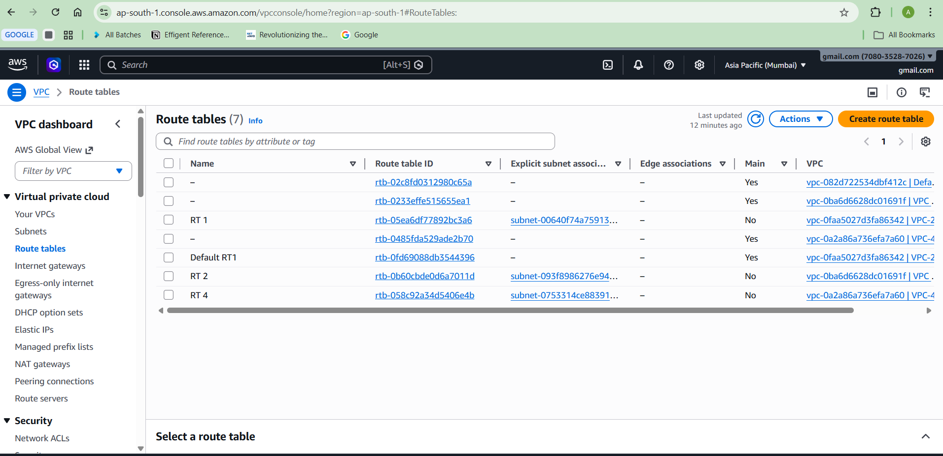
Step 15: Update Route Table of VPC-2
Add routes:
10.0.0.0/28→ Transit Gateway
10.0.0.0/28→ Transit Gateway
Step 16: Update Route Table of VPC-3
Add routes:
10.0.1.0/28→ Transit Gateway
10.0.1.0/28→ Transit Gateway
Step 17: Update Route Table of VPC-3
Add routes:
10.0.2.0/28→ Transit Gateway
10.0.2.0/28/24 → Transit Gateway
Internet Gateway (IGW)
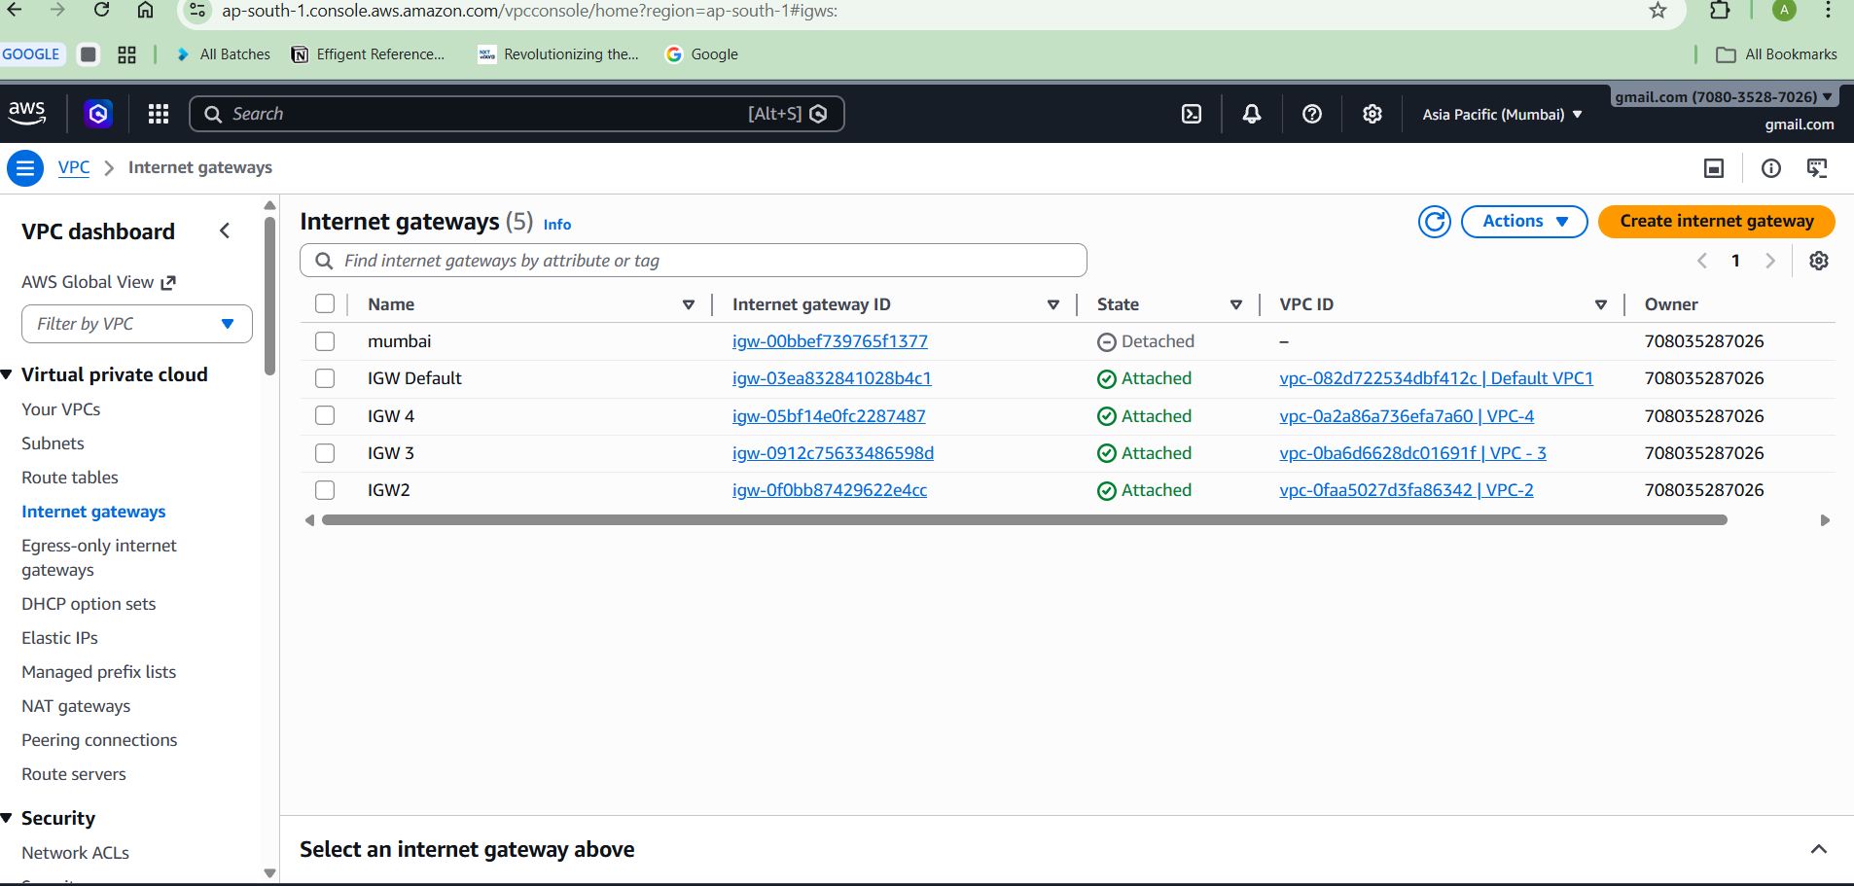
Step 18: Launch EC2 instances in each VPC
Step 19: Test connectivity using ping between EC2 private IP addresses

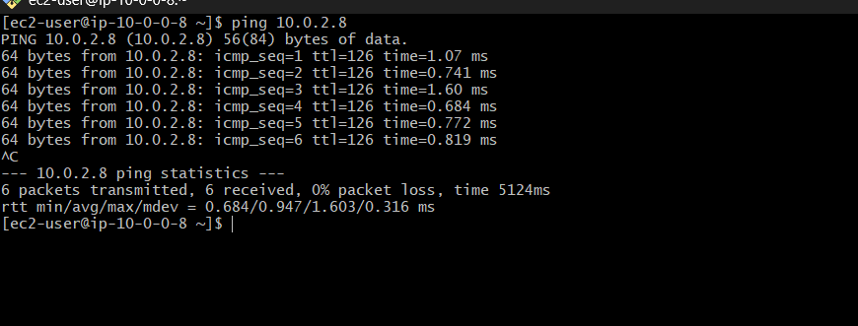

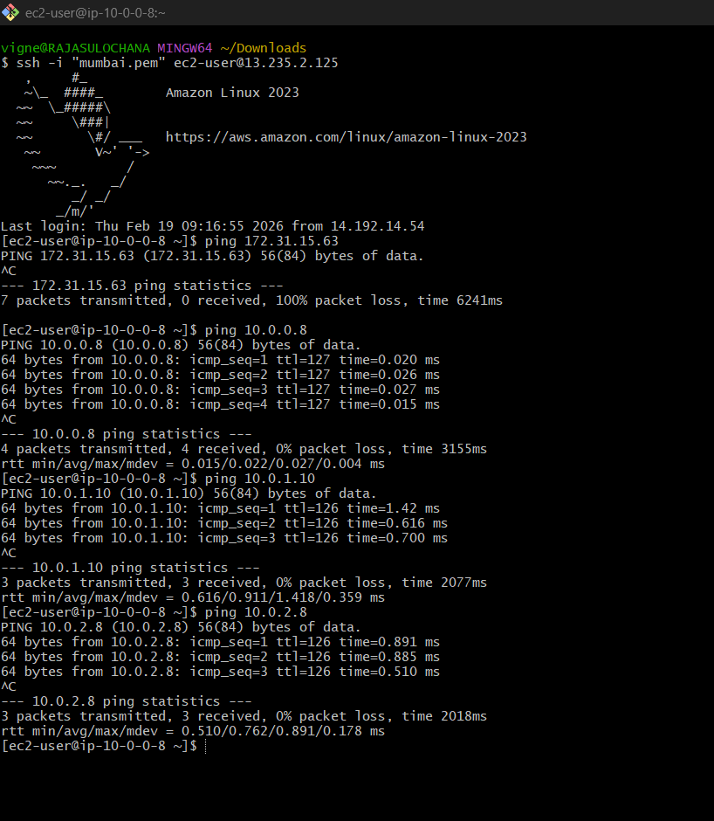

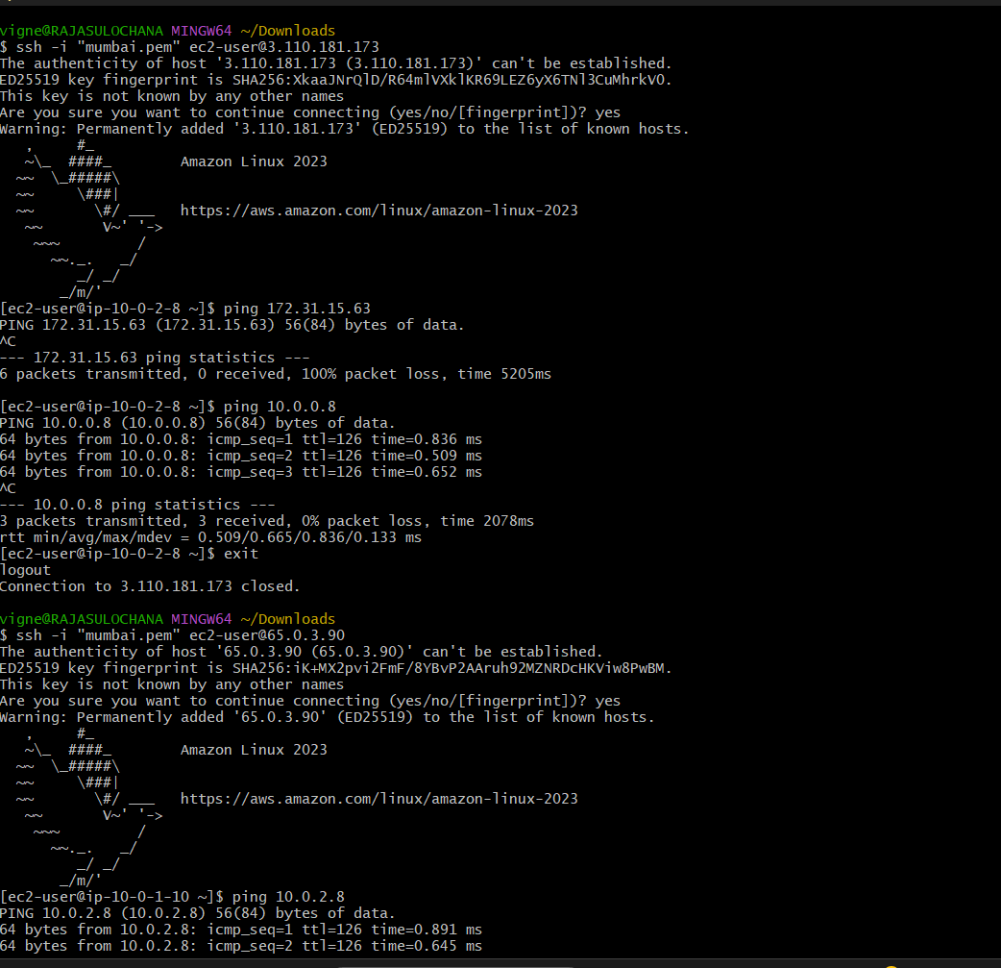

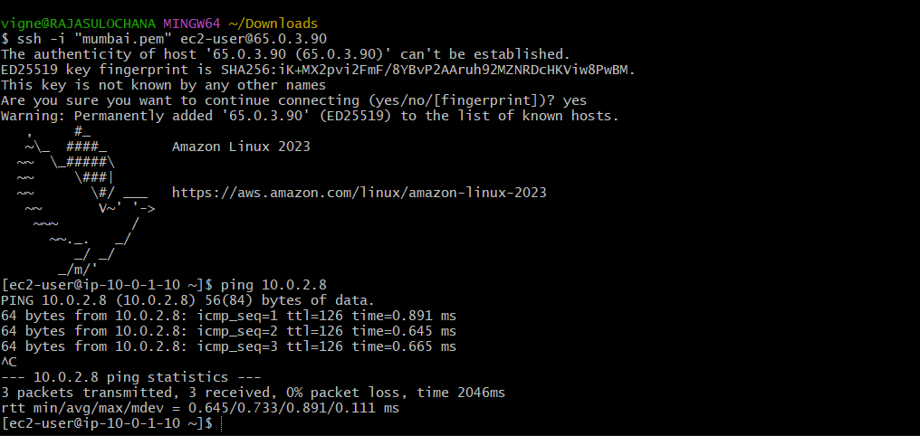

Result: Transit Gateway successfully connects all VPCs.
2) AWS Bastion Server and VPC Endpoint
Task 2: VPC Endpoints Setup -
Configuring Private AWS Service Access Using VPC Endpoints
How to create a VPC, Bastion Server, Private Server, and S3 VPC Endpoint
step-by-step.

STEP 1: Create VPC
Go to AWS Console → VPC → Create VPC
Name: MyVPC
CIDR: 192.168.0.0/16
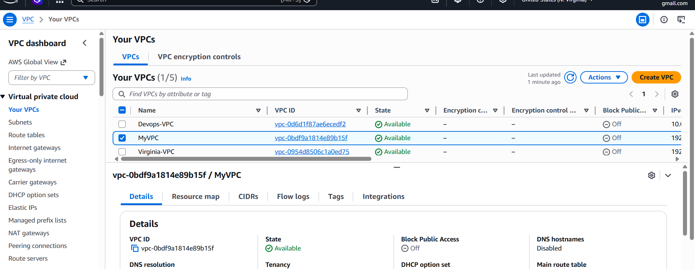
STEP 2: Create Public Subnet
Name: Public-Subnet
CIDR: 192.168.0.0/24
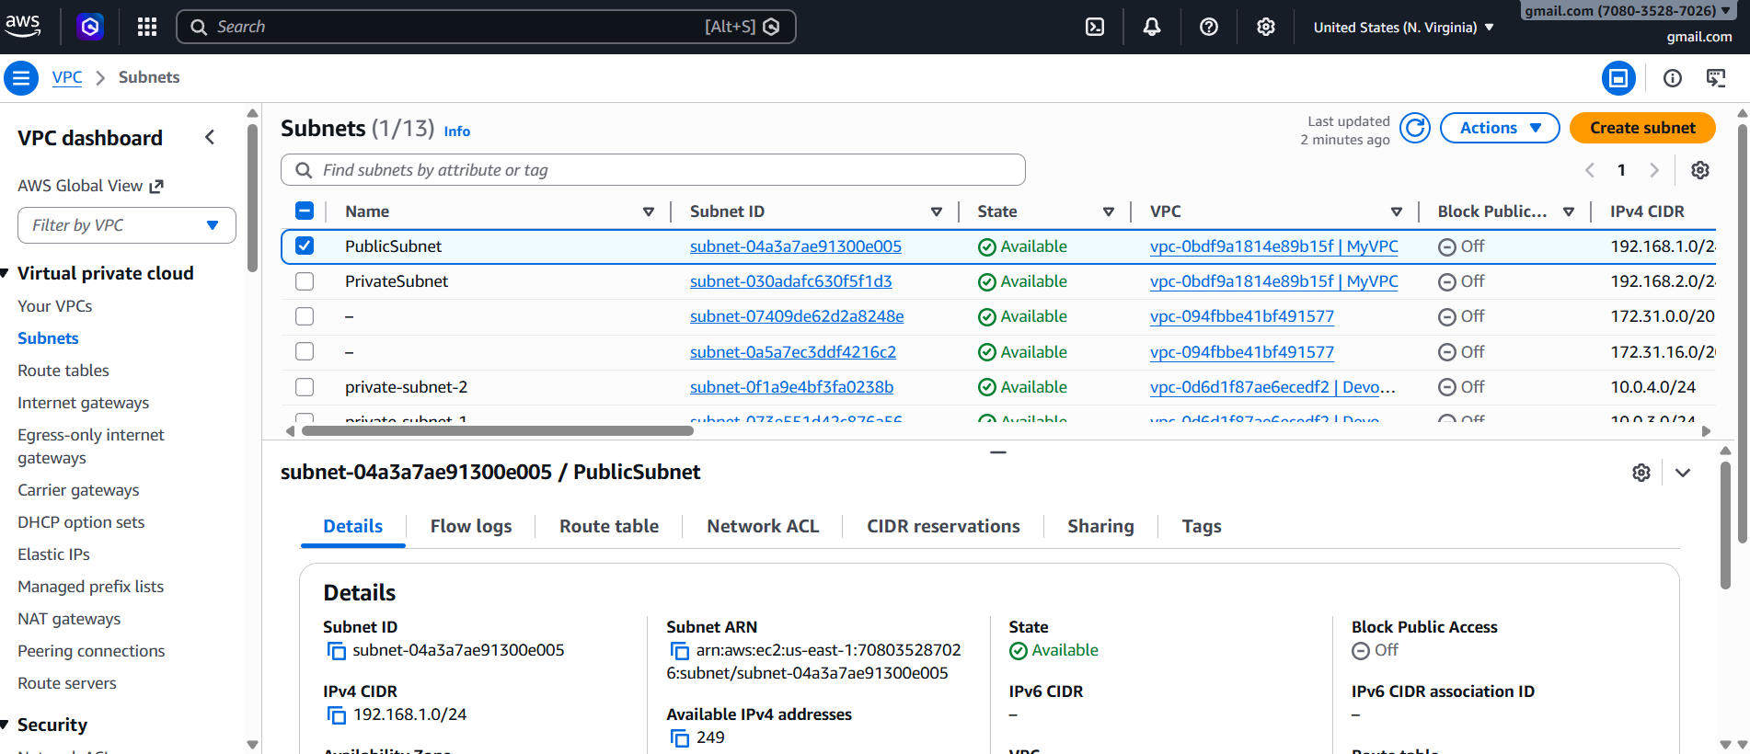
STEP 3: Create Private Subnet
Name: Private-Subnet
CIDR: 192.168.1.0/24
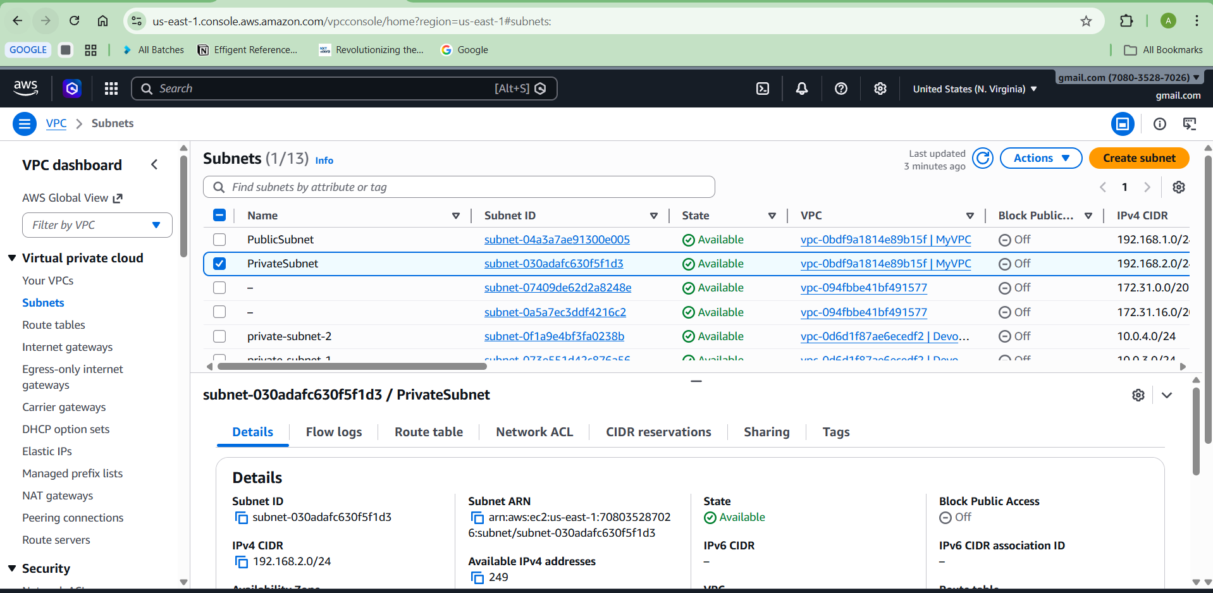
STEP 4: Create Internet Gateway
Attach Internet Gateway to MyVPC
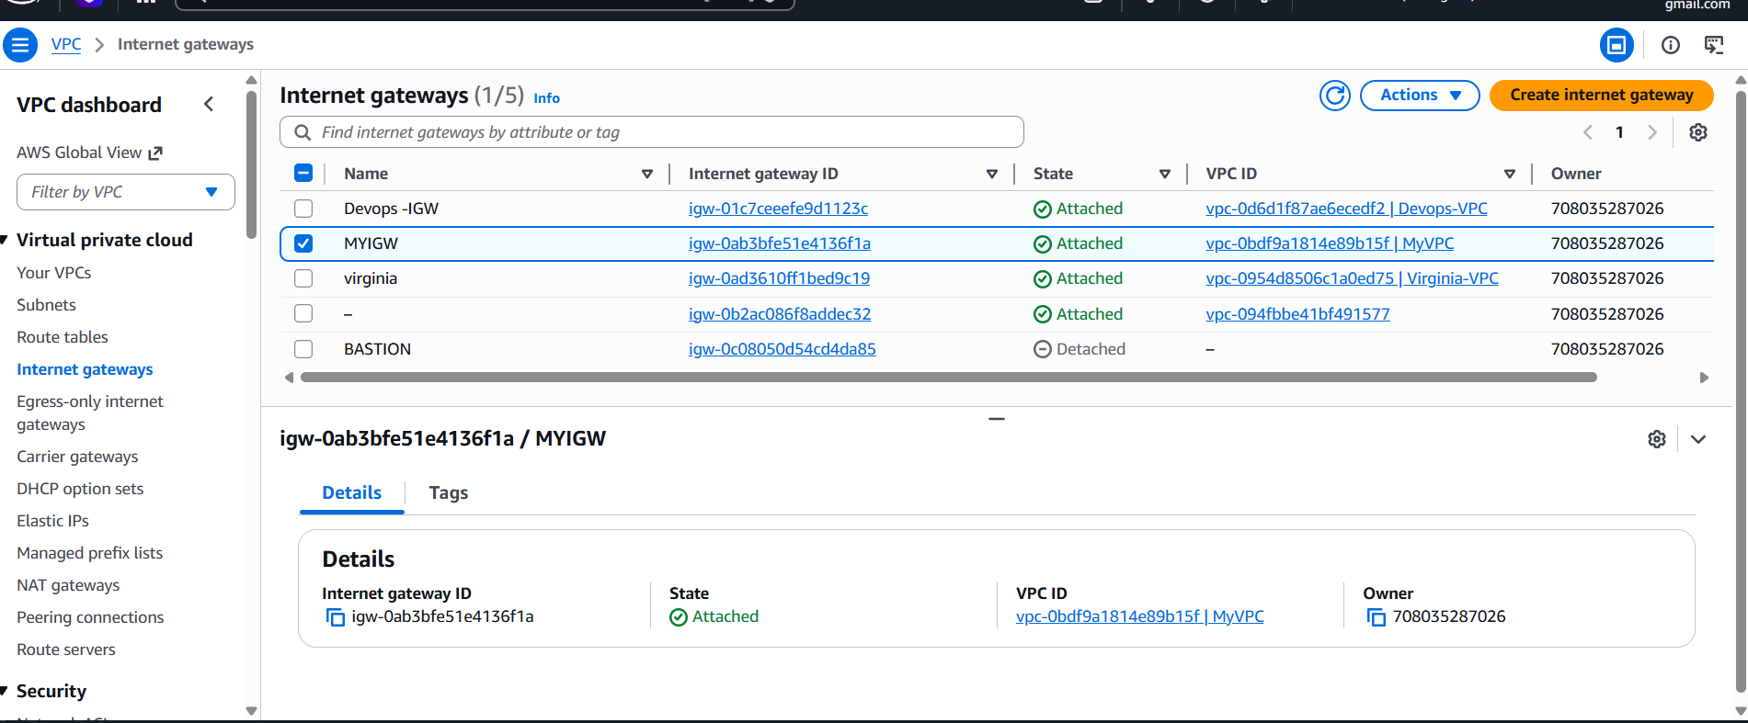
STEP 5: Create Public Route Table
Add route: 0.0.0.0/0 → Internet Gateway
Associate Public Subnet
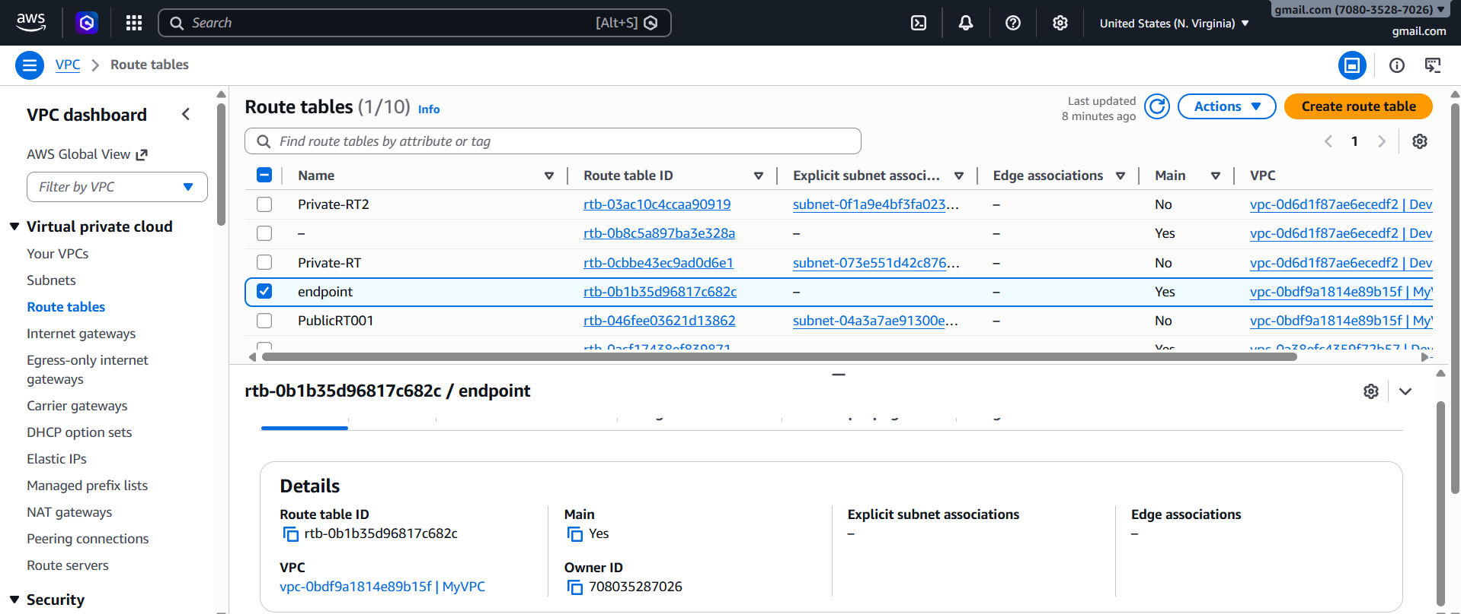
STEP 6: Create Private Route Table
Associate Private Subnet
Do not add Internet Gateway

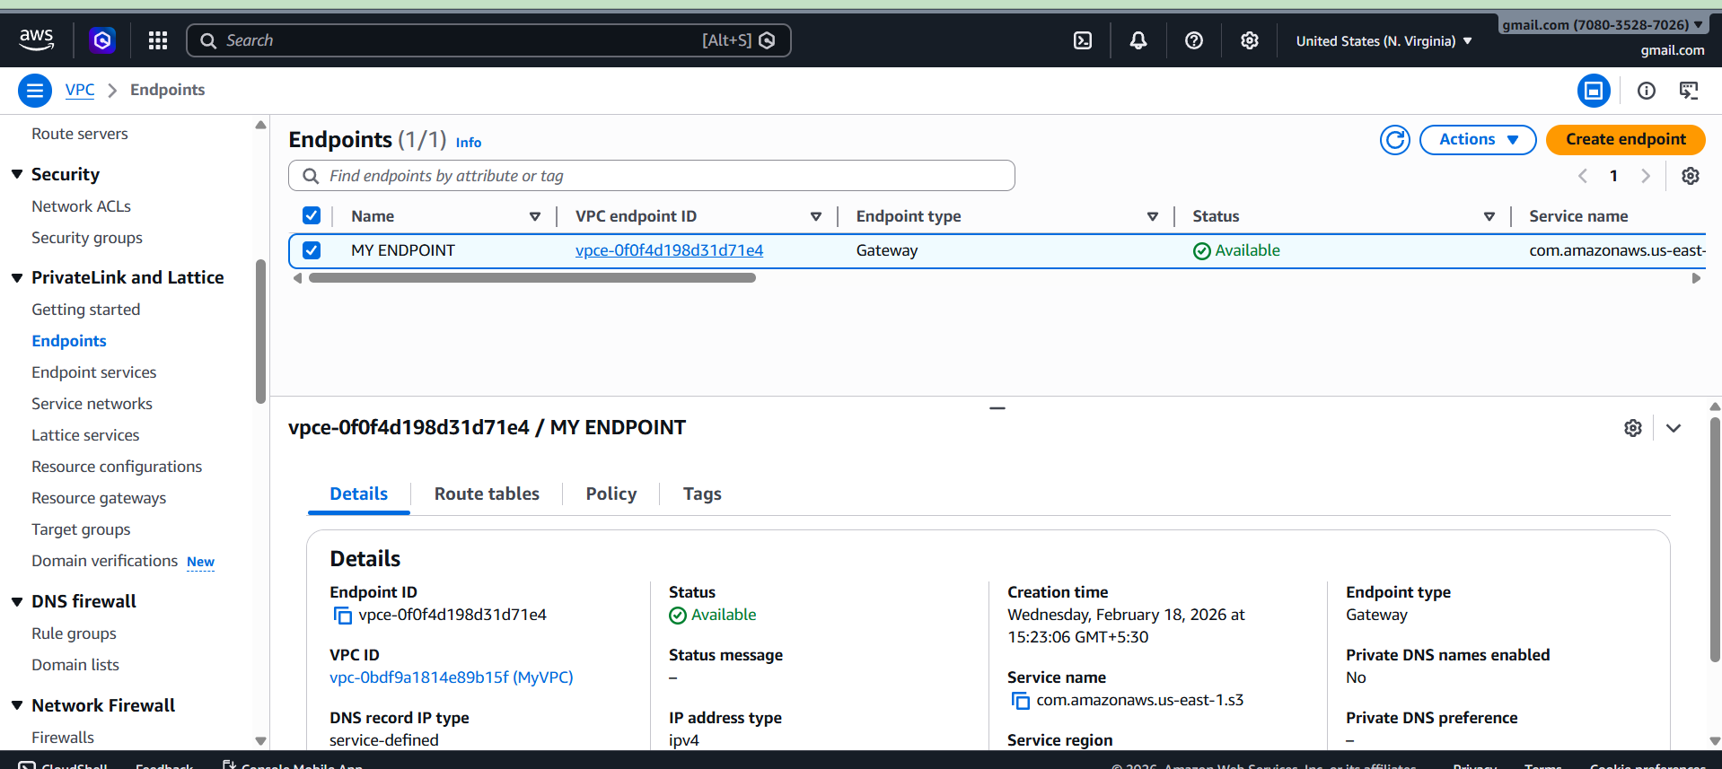

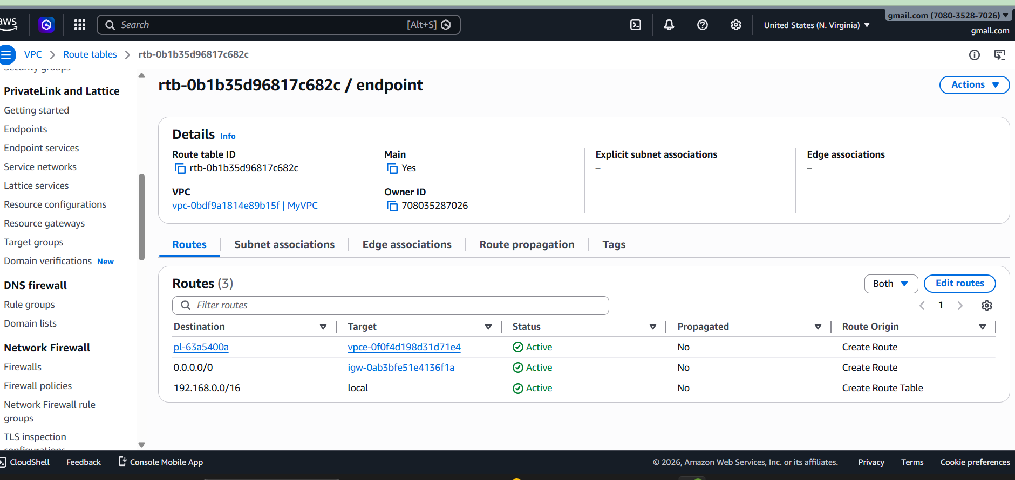
STEP 7: Launch Bastion Server
Launch EC2 in Public Subnet
Enable Public IP
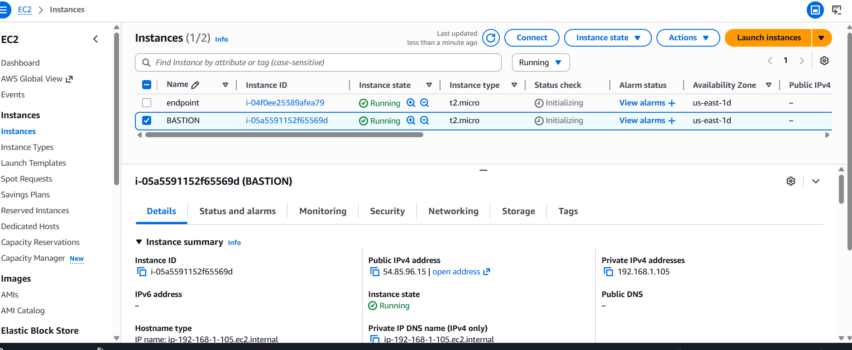

STEP 8: Launch Private Server
Launch EC2 in Private Subnet
Disable Public IP
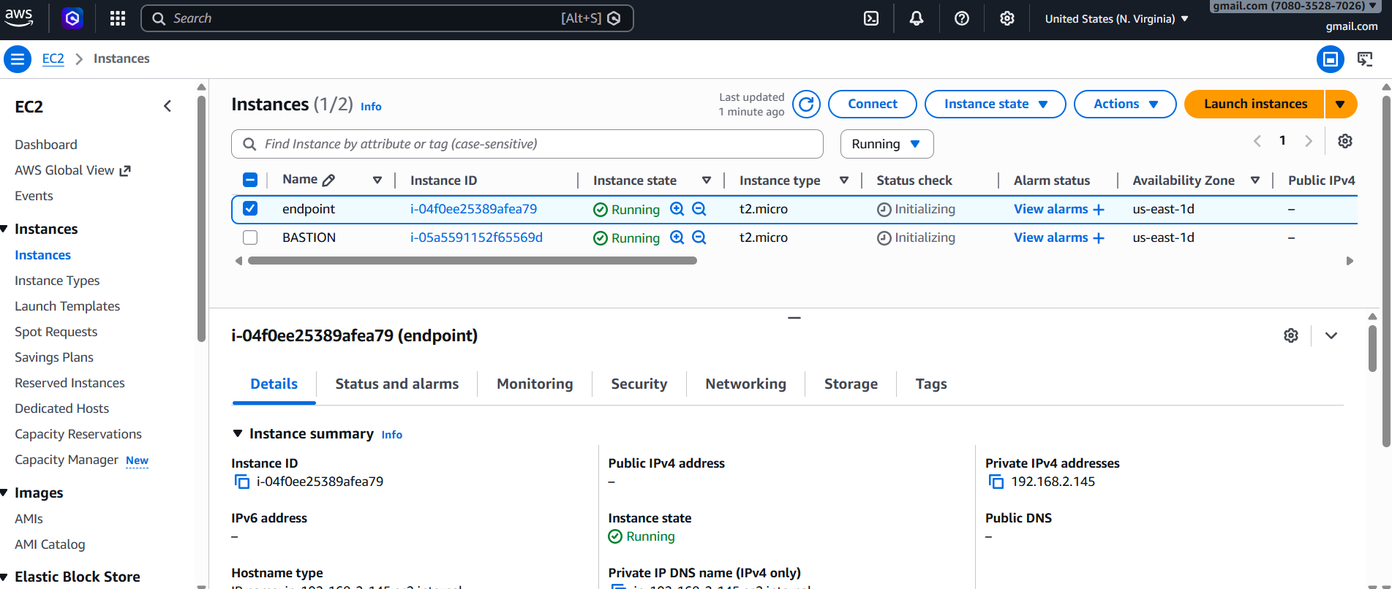
STEP 9: Connect to Bastion Server
Use EC2 Instance Connect

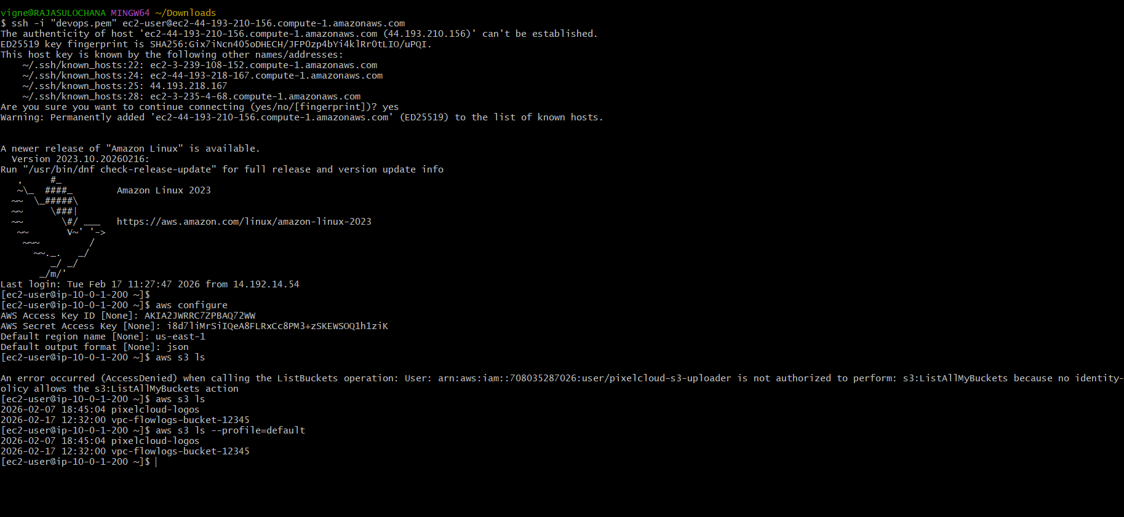

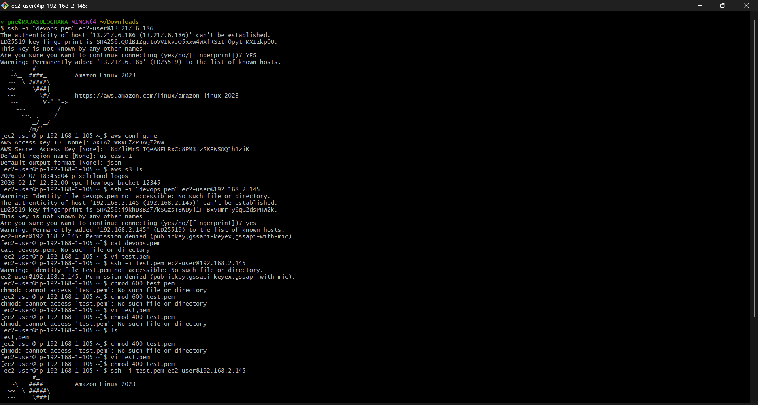

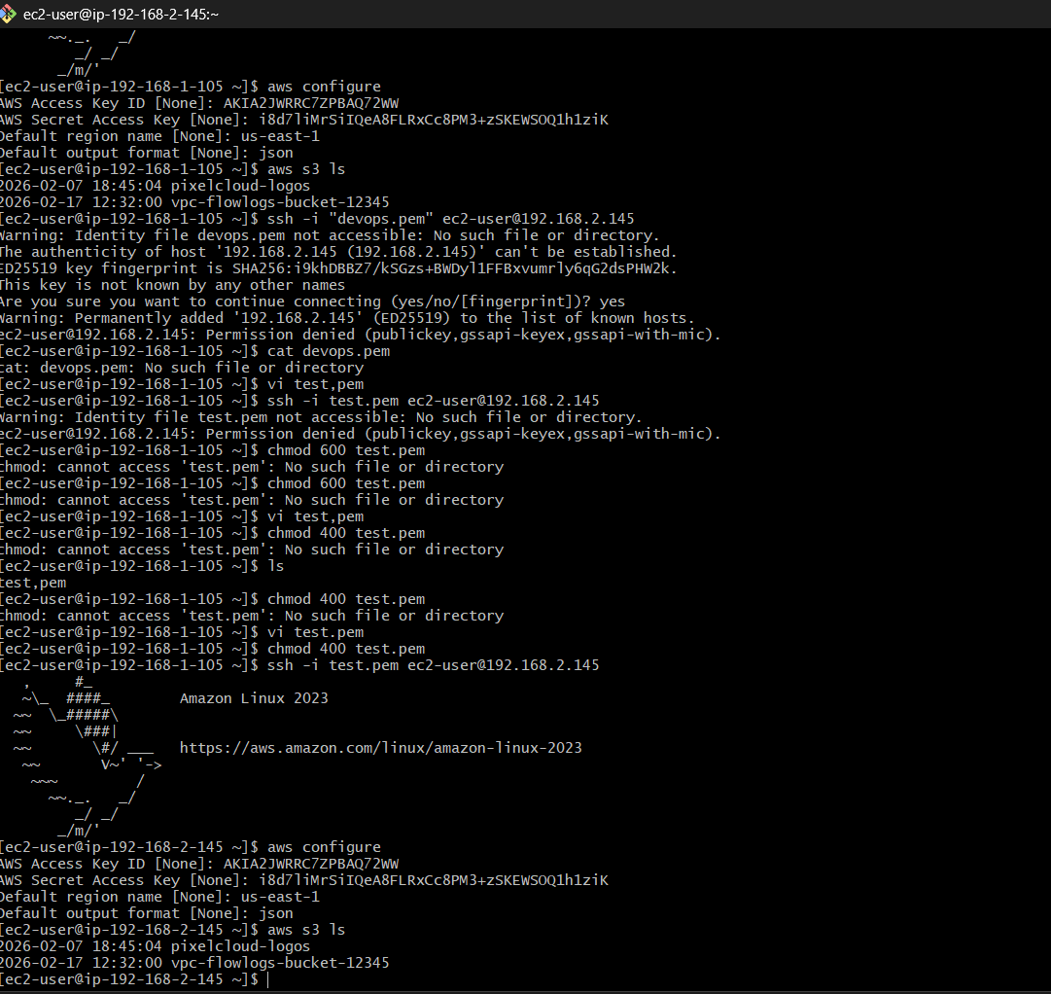

If successful, endpoint is working.
Architecture:
Laptop → Bastion Server → Private Server → VPC Endpoint → Amazon S3

